Dear Pastor:

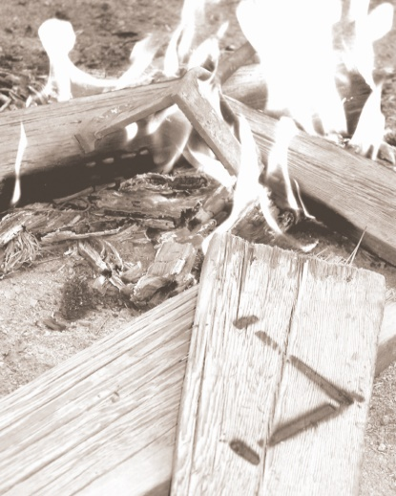

of decision

a

PLACE

IRONWOOD

Howdy from Ironwood! Ironwood is located in southern California and serves churches all across the southwestern United States. Every summer a small percentage of adults sacrifice to participate in some type of summer ministry opportunity. Some go on mission trips, some serve in camps, and some intern with churches. Each week we see nearly 300 young people at camp, and about 10% of our campers will accept Christ as their personal Savior. Countless others will make important steps of growth in Christlikeness and make other life-changing decisions. Among the most important life-changing decisions made at camp this summer will be the decisions made by those who serve the Lord on our summer staff. We know from past experience that this ministry opportunity will forever impact each staff member. They will see God work miracles in the lives of campers each week, and they will see God use them in this amazing process.

We would like you to consider allowing the young person who sent you this letter to present their summer ministry opportunity to your congregation. We have asked them to talk to you about presenting their summer ministry to your church. You can preview our ministry on our website ([www.ironwoodcamp.org](http://www.ironwoodcamp.org)), YouTube channel ([www.youtube.com/user/IronwoodOnline](http://www.youtube.com/user/IronwoodOnline)), or our Facebook page ([www.facebook.com/campironwood](http://www.facebook.com/campironwood)).

You or your folks can participate in supporting summer staff this summer in several ways. We want each of our staff members to enlist the participation of as many people as possible to uphold them in prayer. We have prepared some pledge cards for those who would pledge to pray for them. You can also sign up to receive a weekly e-mail update of what God is doing at camp over the summer.

Those who are interested and able may give financial support. Serving on our summer staff is a step of faith. The financial needs are twofold. First is the cost of getting to Ironwood this summer, and second is the college scholarship fund. Many of our summer staff would be unable to return to school next year without the additional help of our summer staff scholarship program. In addition to praying, would you consider taking up a love offering for your young person? We would suggest that you ask them about how these gifts would be most helpful. Transportation and expenses gifts should go directly to them and scholarship funds should be written to Ironwood and designated for the individual. Each summer staffer enrolled in the scholarship program gets $250/week towards their scholarship fund plus whatever gets raised in their name. Each summer thriver enrolled in the scholarship program gets $150/week towards their scholarship fund plus whatever gets raised in their name. Be sure to designate your donation to a particular person to ensure they get your gift. Any undesignated scholarship funds will be applied to the needs of our other summer staff through our general summer staff scholarship fund.

Thank you so much for allowing us this opportunity with your young person!



Sam Brock

Executive Director

*Ironwood is a home missions ministry using the unique aspects of the camping ministry to reach young people for the Lord Jesus Christ,   
strengthen families, and serve local churches. It is a place of decision in the areas of salvation, full surrender, and consistent Christian walk.*

**IRONWOOD t 49191 Cherokee Road t Newberry Springs, CA 92365 t www.ironwoodcamp.org**

49191 Cherokee Road •  Newberry Springs, CA 92365 •  www.ironwood.org

Ironwood is a home missions ministry using the unique aspects of the camping ministry to reach young people for the Lord Jesus Christ, strengthen families and serve the local churches. It is a place of decision in the areas of salvation, full surrender and consistent Christian growth.

49191 Cherokee Road •  Newberry Springs, CA 92365 •  www.ironwood.org

Ironwood is a home missions ministry using the unique aspects of the camping ministry to reach young people for the Lord Jesus Christ, strengthen families and serve the local churches. It is a place of decision in the areas of salvation, full surrender and consistent Christian growth.